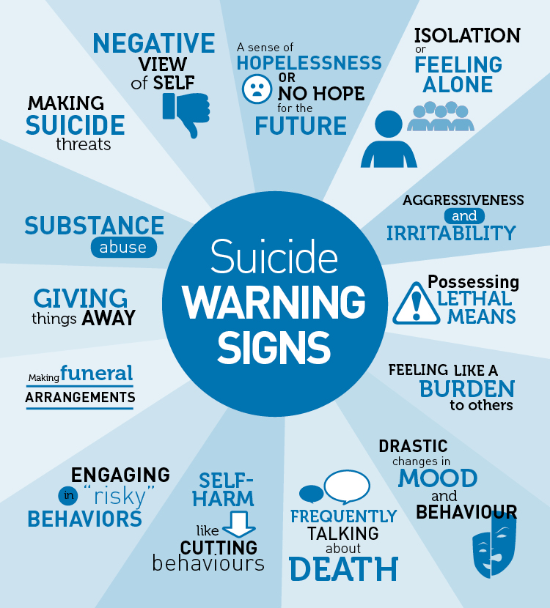



**Suicide Prevention Training for Parents**

**QPR (Question.Persuade.Refer)**

Dates:

Thursday, November 1st

Tuesday, December 4th

Wednesday, January 9th

Time: 6:00 – 7:00 P.M.

Location: Tanglewood Elementary School

3060 Overton Park Drive West

School Auditorium