Tangelwood Communications
Beginning 7/1/19, we will be switching over to the FWISD ParentLink communication system to send out updates and reminders to parents. This will replace the Tanglewood Parents Remind app messages. Teachers may continue to create their own Remind groups for parents, but the size of our school community group is too large to continue to qualify for a free Remind account (150 members or less). To receive messages from Tanglewood on the FWISD ParentLink system, please follow the steps below:
- Download the FWISD app on your phone

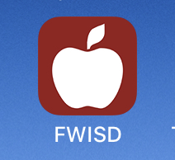

- Swipe left twice and click on settings

- Tap on Follow Schools

- Select Tanglewood ES

- Choose the notifications you wish to receive (ALL)

If you already have a parent portal account, you may configure your settings to receive these messages via text as well. To sign up for the Parent Portal, visit https://www.fwisd.org/parentportal.
We will continue to post to our closed Facebook group (Tanglewood Elementary Parents) and send weekly e-blasts via tanglewoodpta.org. Weekly e-blasts will resume in August.
Please email questions to dana.mckenzie@fwisd.org

